Round Robin Scheduling Algorithm

Round Robin is a CPU Scheduling Algorithm where each process is assigned a fixed time slot in a cyclic way.
- It is simple, easy to implement, and starvation-free as all processes get fair share of CPU.
- One of the most commonly used technique in CPU scheduling as a core.
- It is preemptive as processes are assigned CPU only for a fixed slice of time at most.
- The disadvantage of it is more overhead of context switching.

Implementation in C

Source code:

#include<bits/stdc++.h>
using namespace std;

main()
{
int n;

printf("Enter the number of processes:");
scanf("%d",&n);
int b[n],a[n],w[n],p[n],tq,flag=0,i,k,temp[100],total=0;
for(i=0; i<n; i++)
{
printf("enter burst time of process%d:",i+1);
scanf("%d",&b[i]);
w[i]=0;
p[i]=0;

}

printf("Enter the time quantum:");
scanf("%d",&tq);
i=0;
k=0;

while(1)
{
if(i==n)
i=0;
if(flag==n)
break;

if(b[i]<=tq && b[i]>0)
{
w[i]+=total-p[i];
flag++;

total+=b[i];
b[i]=0;
temp[k]=i;
k++;

}
if(b[i]>tq)
{
w[i]+=total-p[i];
b[i]=b[i]-tq;
total+=tq;
temp[k]=i;
k++;
}
p[i]=total;
i++;
}
printf("\nOrder of execution:\n");
for(i=0; i<k; i++)
{
printf("P%d ",temp[i]+1);
}

int a_w_time=0;
for(i=0; i<n; i++)
{
printf("\nP%d Waiting time %d\n",i+1,w[i]);
a_w_time = a_w_time + w[i];

}
printf("\nAverage Waiting time %.4f\n",((float)a_w_time/(float)n));

}

Output :
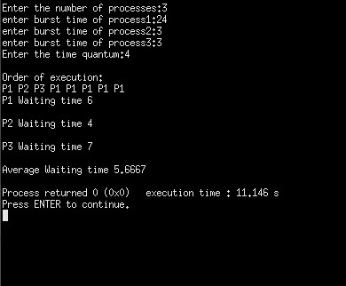

Conclusion :

Round Robin is a exceptional CPU scheduling algorithm and easy to implement in c . It work base on the quanta time.

